Paper Title*

Weiqiang Ying1, Cheng Kuang1, Lingyan Zhang1, Cheng Yao1, Fangtian Ying1 and Shijian Luo1*

1dept. name of organization (of Aff.), City, codenum,Country.

*Corresponding author(s). E-mail(s): author@gmail.com; Contributing authors: author@gmail.com; author@gmail.com; author@gmail.com;

**Abstract**

This template, modified in MS Word 2007 and saved as a “Word 97-2003 Document” for the PC, provides authors with most of the formatting specifications needed for preparing electronic versions of their papers. All standard paper components have been specified for three reasons: (1) ease of use when formatting individual papers, (2) automatic compliance to electronic requirements that facilitate the concurrent or later production of electronic products, and (3) conformity of style throughout a conference proceeding. Margins, column widths, line spacing, and type styles are built-in; examples of the type styles are provided throughout this document and are identified in italic type, within parentheses, following the example. Some components, such as multi-leveled equations, graphics, and tables are not prescribed, although the various table text styles are provided. The formatter will need to create these components, incorporating the applicable criteria that follow.

**Keywords:** PID Control, Yaw Correction, Trajectory Planning

1

# 1 Introduction

The template will number citations consecutively within brackets [1]. The sentence punctuation follows the bracket[2–4]. Refer simply to the reference number, as in [2–4]—do not use “Ref. [2–4]” or “reference \cite{HUANG2021108586}” except at the beginning of a sentence: “Reference [2–4] was the first ...”

These guidelines, written in the style of a submission to J. Phys.: Conf. Ser., show the best layout for your paper using Microsoft Word. If you don’t wish to use the Word template provided, please use the following page setup measurements [5–7].

Number footnotes separately in superscripts. Place the actual footnote at the bottom of the column in which it was cited. Do not put footnotes in the abstract or reference list. Use letters for table footnotes.

Unless there are six authors or more give all authors’ names; do not use “et al.”. Papers that have not been published, even if they have been submitted for publication, should be cited as “unpublished”. Papers that have been accepted for publication should be cited as “in press”. Capitalize only the first word in a paper title, except for proper nouns and element symbols.

For papers published in translation journals, please give the English citation first, followed by the original foreign-language citation.

# Figure

Each figure should have a brief caption describing it and, if necessary, a key to interpret the various lines and symbols on the figure (Fig.1).

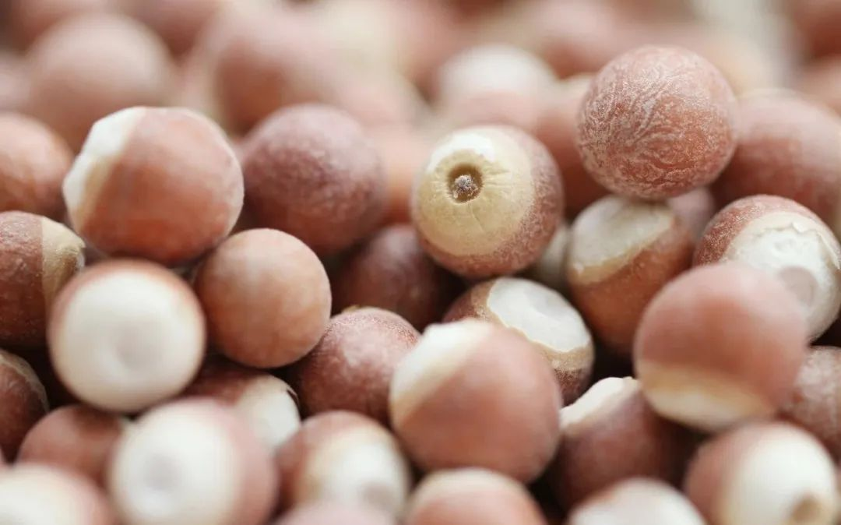

**Fig. 1** Main structure

Figure Labels: Use 8-point Times New Roman for Figure labels. Use words rather than symbols or abbreviations when writing Figure axis labels to avoid confusing the reader. As an example, write the quantity “Magnetization”, or “Magnetization, M”, not just “M”. If including units in the label, present them within parentheses. Do not label axes only with units. In the example, write “Magnetization (A/m)” or “Magnetization {A[m(1)]}”, not just “A/m”. Do not label axes with a ratio of quantities and units. For example, write “Temperature (K)”, not “Temperature/K”.

# Ease of use

First, confirm that you have the correct template for your paper size. This template has been tailored for output on the A4 paper size. If you are using US letter-sized paper, please close this file and download the Microsoft Word, Letter file.

# Equation

The equations are an exception to the prescribed specifications of this template. You will need to determine whether or not your equation should be typed using either the Times New Roman or the Symbol font (please no other font). To create multileveled equations, it may be necessary to treat the equation as a graphic and insert it into the text after your paper is styled

[8, 9]. There is the following relation Eq.1.

$$\begin{aligned}ΔL=L_{1}⋅\left(1-\cos{θ}\right)\#\left( AUTONUM \backslash * Arabic \right)\end{aligned}$$

$$\begin{aligned}a={ΔL}/R\#\left( AUTONUM \backslash * Arabic \right)\end{aligned}$$

Note that the equation is centered using a center tab stop. Be sure that the symbols in your equation have been defined before or immediately following the equation. Use “(1)”, not “Eq. (1)” or “equation (1)”, except at the beginning of a sentence: “Equation (1) is . . .”

When $Δθ$ is small, $ΔL≈\left|e_{r}\right|⋅Δθ=Δθ$, if the ramp arc length s is taken as coordinate, $ν=\frac{ⅆs}{ⅆt}$, $a_{t}=\frac{ⅆv}{ⅆt}$, the corresponding formula.

$$\begin{aligned}ΔL=S-S_{0}=\int_{0}^{t}{}\left(V_{0}+\int_{0}^{t}{a_{t}⋅ⅆt}\right)⋅ⅆ_{t}\#\left( AUTONUM \backslash * Arabic \right)\end{aligned}$$

$$\begin{aligned}\overline{a}=\frac{ΔL}{R}\#\left( AUTONUM \backslash * Arabic \right)\end{aligned}$$

where, $\overline{a }$ is the yaw angle of the mobile robot; $S-S_{0}$ is the length of the ramp; $Δθ$ is the variation of the angle between the ramp $θ$ and the ground.

# Table

Positioning Figures and Tables: Place figures and tables at the top and bottom of columns. Avoid placing them in the middle of columns. Large figures and tables may span across both columns. Figure captions should be below the figures; table heads should appear above the tables. Insert figures and tables after they are cited in the text.

Use the abbreviation “Fig. 1”, even at the beginning of a sentence Fig.1.

**Table 1.** Table Head

|  |  |  |  |  |  |  |
| --- | --- | --- | --- | --- | --- | --- |
| Table Head | Subhead | Subhead | Subhead |  |  |  |
| **F1** | 1.143 | 0.285 | 0.286 |  |  |  |
| **F2** | 1.143 | 0.285 | 0.067 |  |  |  |
|  |  |  |  |  |  |  |

# PREPARE YOUR PAPER BEFORE TYLING

Before you begin to format your paper, first write and save the content as a separate text file. Complete all content and organizational editing before formatting. Please note sections A-C below for more information on proofreading, spelling and grammar.

Keep your text and graphic files separate until after the text has been formatted and styled. Do not use hard tabs, and limit use of hard returns to only one return at the end of a paragraph. Do not add any kind of pagination anywhere in the paper. Do not number text heads-the template will do that for you.

A. Abbreviations and Acronyms

Define abbreviations and acronyms the first time they are used in the text, even after they have been defined in the abstract. Abbreviations such as IEEE, SI, MKS, CGS, sc, dc, and rms do not have to be defined. Do not use abbreviations in the title or heads unless they are unavoidable.

B. Units

• Use either SI (MKS) or CGS as primary units. (SI units are encouraged.) English units may be used as secondary units (in parentheses). An exception would be the use of English units as identifiers in trade, such as “3.5-inch disk drive”.

• Avoid combining SI and CGS units, such as current in amperes and magnetic field in oersteds. This often leads to confusion because equations do not balance dimensionally. If you must use mixed units, clearly state the units for each quantity that you use in an equation.

• Do not mix complete spellings and abbreviations of units: “Wb/m2” or “webers per square meter”, not “webers/m2”. Spell out units when they appear in text: “. . . a few henries”, not “. . . a few H”.

• Use a zero before decimal points: “0.25”, not “.25”. Use “cm3”, not “cc”. (bullet list)

C. Some Common Mistakes

• The word “data” is plural, not singular.

• The subscript for the permeability of vacuum μ0, and other common scientific constants, is zero with subscript formatting, not a lowercase letter “o”.

• In American English, commas, semicolons, periods, question and exclamation marks are located within quotation marks only when a complete thought or name is cited, such as a title or full quotation. When quotation marks are used, instead of a bold or italic typeface, to highlight a word or phrase, punctuation should appear outside of the quotation marks. A parenthetical phrase or statement at the end of a sentence is punctuated outside of the closing parenthesis (like this). (A parenthetical sentence is punctuated within the parentheses.)

• A graph within a graph is an “inset”, not an “insert”. The word alternatively is preferred to the word “alternately” (unless you really mean something that alternates).

• Do not use the word “essentially” to mean “approximately” or “effectively”.

• In your paper title, if the words “that uses” can accurately replace the word “using”, capitalize the “u”; if not, keep using lower-cased.

• Be aware of the different meanings of the homophone’s “affect” and “effect”, “complement” and “compliment”, “discreet” and “discrete”, “principal” and “principle”.

• Do not confuse “imply” and “infer”.

• The prefix “non” is not a word; it should be joined to the word it modifies, usually without a hyphen.

# 8 Conclusion

The template is used to format your paper and style the text. All margins, column widths, line spaces, and text fonts are prescribed; please do not alter them. You may note peculiarities. For example, the head margin in this template measures proportionately more than is customary. This measurement and others are deliberate, using specifications that anticipate your paper as one part of the entire proceedings, and not as an independent document. Please do not revise any of the current designations.

# DECLARATIONS

## Ethics approval and consent to participate

Not applicable.

## Conflict of interest

No potential conflict of interest was reported by the authors.

## Dataset to be available

All data generated or analyzed during this study are included in this published article.

## Consent for publication

Not applicable.

## Funding

Not applicable

## Acknowledge

The preferred spelling of the word “acknowledgment” in America is without an “e” after the “g”. Avoid the stilted expression “one of us (R. B. G.) thanks ...”. Instead, try “R. B. G. thanks...”. Put sponsor acknowledgments in the unnumbered footnote on the first page.

## Authors’ information

xxx is a lecturer in information product Design, School of Software, Zhejiang University. He is Deputy Director of the Engineering Center for Innovative Design of Computer-aided Products of the Ministry of Education and a member of the International Society for Computing Machinery (ACM).

He is mainly engaged in the research of information product design, technology design, human-computer interaction, industrial design, digital art and design.

## Abbreviatiuons

PID proportional-integral-derivative

DC direct current motor

CDU current differential unit

CRU current replication unit

CSU current squarer unit

TAU transconductance amplifier unit

CDBA current differential buffer amplifier

AR augmented reality

ADC voltage double closed-loop

RTK real-time kinematic

# Appendix A Relevant data and information

# References

* + 1. Takagi, M. T.and Sugeno: Fuzzy identification of systems and its appli- cation to modeling and control (1985)
    2. Kumar, G. A.and Hancke, Phala, K.S.: Air quality monitoring system based on iso/iec/ieee 21451 standards. IEEE Sensors Journal **16**(12), 5037–5045 (2016)
    3. Mester, G.: Motion control of wheeled mobile robots modeling of the wheeled mobile robots (2006)
    4. Hancke, G.P., Markantonakis, K.E. K.and Mayes: Security challenges for user-oriented rfid applications within the “internet of things”. Journal of Internet Technology **11**(3), 7 (2010)
    5. Erdem, A.T., Ercan, A.O.: Fusing inertial sensor data in an extended kalman filter for 3d camera tracking. IEEE Transactions on Image Processing **24**(2), 538–548 (2015)
    6. Azuma, R.T.: A survey of augmented reality. Presence: Teleoperators and Virtual Environments **6**(4), 355–385 (1997)
    7. Benser, E.T.: Trends in inertial sensors and applications. In: 2015 IEEE International Symposium on Inertial Sensors and Systems (ISISS) Proceedings (2015)
    8. Coito, F., Eleutério, A., Valtchev, S.: Tracking a mobile robot position using vision and inertial sensor. In: Doctoral Conference on Computing, Electrical and Industrial Systems (2014)
    9. Hol, J.D., SchöN, T.B., Luinge, H., Slycke, P.J., Gustafsson, F.: Robust real-time tracking by fusing measurements from inertial and vision sensors. Journal of Real-Time Image Processing **2**(2-3), 149–160 (2007)