A randomized controlled trial of Cross-Modal Art Therapy System integrated with cognitive behavioral therapy for insomnia: Neurophysiological mechanisms and clinical efficacy
B.N. Author ^{1,}, B.N. Author² and C.N. Author³
¹1st dept. name of organization (of Aff.) ,City, Country
²2nd Author’s affiliation, Author’s address
³3rd Author’s affiliation, Author’s address
Abstract
This paper explores the application of artificial intelligence (AI) technology in the field of artistic creation and its profound impact on the cultural industry. AI technology, by simulating human thinking and emotions, has driven the intelligence, interactivity, and dataization of artistic expression. Computational creativity, as a branch of AI, has shown great potential in food innovation and artistic creation. The integration of AI with art education enhances students' creativity, while the development of AI-assisted writing technology can be traced back to the early 20th century. The application of AI in art design, such as the use of genetic algorithms in music composition and Generative Adversarial Networks (GAN) in digital art, demonstrates the important role of AI technology in artistic creation.

Keywords: Insomnia Disorder, Cross-Modal Art Therapy, Cognitive Behavioral Therapy for Insomnia (CBT-I), System Design, Electroencephalography (EEG), Heart Rate Variability (HRV).
Received on DD MM YYYY, accepted on DD MM YYYY, published on DD MM YYYY

Copyright © YYYY Author et al., licensed to EAI. This is an open access article distributed under the terms of the CC BY-NC-SA 4.0, which permits copying, redistributing, remixing, transformation, and building upon the material in any medium so long as the original work is properly cited.

doi: 10.4108/_______________

1. Introduction
Insomnia disorder (ID) is a widespread public health problem characterized by persistent difficulties in the initiation, duration, consolidation or quality of sleep, leading to significant daytime functional impairment [1]. Globally, the prevalence of chronic insomnia ranges from 10% to 30%, exerting a profound impact on mental health, cognitive function, and the risk of chronic diseases such as hypertension and diabetes [2][3]. Although drug treatment can immediately relieve symptoms, it is often associated with side effects and dependence, and cannot solve underlying behavioral and cognitive problems [4]. Non-pharmacological treatment is widely regarded as the preferred, safe and effective intervention method in the intervention of insomnia disorders, especially suitable for long-term management and reducing the risk of drug side effects [5]. At present, the gold standard for the treatment of chronic ID is insomnia cognitive Behavioral Therapy (CBT-I) [6]. CBT-I is a multi-component intervention aimed at addressing the cognitive and behavioral factors that lead to the persistence of insomnia. Although traditional CBT-I is highly effective, its efficacy may be limited by patient compliance, the availability of trained therapists, and the lack of direct and real-time physiological regulation [7].
Emerging research in the intersection of design, technology and neuroscience indicates that precisely controlled sensory stimulation can directly influence brain state and autonomic nervous system (ANS) activity [8]. Art therapy, especially its cross-modal or interdisciplinary forms, utilizes the integration of multiple sensory modes to promote emotional regulation and cognitive reconstruction [9]. However, the application of traditional art therapy in sleep medicine is often in a single form and lacks objective physiological measurements.
This study proposes a cross-modal art therapy system (CMATS) that integrates the principles of CBT-I with auditory, visual and tactile stimuli. Five groups of randomized controlled trials proved that Full-CMATS were superior to single-mode and CBT-I alone in improving indicators such as SL, TST, and PSQI. And through EEG and HRV analysis, it also shows good performance in promoting parasympathetic nerve dominance and enhancing sleep-related brainwave power.
2. Relevant Work
CBT-I is regarded as the preferred treatment for chronic insomnia, and its core components include stimulus control (SC), sleep restriction (SR), relaxation training (RT), and cognitive therapy (CT) [10]. Although effective, its therapeutic effect depends on whether patients can consistently and strictly abide by the behavioral intervention rules. However, for many patients, it is difficult to adhere to these rules for a long time. The recently emerging digital CBT-I (dCBT-I) has been proven to play a positive role in improving sleep, enhancing mental health and quality of life [11], but these platforms mainly focus on providing educational and cognitive content, usually physiological intervention components.
Traditional art therapies, including music therapy, visual art therapy and dance/movement therapy, have been used to treat various psychological and emotional functional disorders [12]. However, these studies usually employ passive listening or simple creative activities. The concept of cross-modal or multi-modal art therapy integrates multiple sensory inputs, providing a richer and more immersive experience [13]. However, due to the lack of intervention systems and quantifiable physiological indicators, these therapies are difficult to be smoothly transformed into widely recognized evidence-based sleep treatment plans in clinical practice.
The integration of wearable technology and neuroscience has enabled the development of systems capable of real-time monitoring and regulation of physiological states [14][15]. Electroencephalogram (EEG) remains the gold standard for objective sleep staging. Specific brainwave frequencies (δ(0.5-4 Hz),θ(4-8 Hz),α(8-12 Hz)) are directly related to sleep depth and quality [16]. Heart rate variability (HRV) is a non-invasive measurement derived from an electrocardiogram (ECG) that can serve as an indicator for detecting the balance status of ANS. Increased parasympathetic nerve activity is crucial for initiating and maintaining sleep [17]. Recent research has begun to utilize these physiological signals for biofeedback and neurofeedback, where sensory stimuli are transmitted based on the user's physiological state to guide them into a good sleep state [18] .
Based on the research of the integration of wearable technology and neuroscience, we have designed the CMATS system. Under the framework of following the standardized treatment process of CBT-I, this system provides cross-modal sensory (auditory, visual, and tactile) input to achieve synchronous intervention of psychology and physiology. This method transforms the traditional qualitative intervention that relies on the therapist's experience into a quantifiable, technology-driven and neurophysiologically validated insomnia treatment plan.
3. Methodology and System Design
3.1 Experimental Plan and Design
This study is a 6-week, single-blind, randomized controlled trial (RCT). This plan has been approved by the XXX Review Committee (Approval Number:...). All participants provided written informed consent.
3.1.1 Participant Recruitment
This study recruited 100 participants (50 males and 50 females, with an average age of 44.8±9.1 years) diagnosed with primary insomnia disorder according to DSM-5, who were able to sleep alone in at least one bed during the experiment. The recruitment methods included online recruitment and clinical recommendation. Exclusion criteria include: 1) The presence of other major sleep disorders (e.g., sleep apnea, restless legs syndrome); 2) Unstable medical or mental conditions; 3) Shift work; And 4) Currently using psychotropic drugs or sleep AIDS.
3.1.2 Research Design and Procedures
To evaluate the effectiveness of the cross-modal method, participants were randomly assigned to one of five parallel groups (n=20 in each group) :
- Control group (CBT-I only) : Received the standard CBT-I protocol.
- Audience-only group (A-CMATS) : Received CBT-I and used the audience-only stimulation module of CMATS every night.
- Vision-only Group (V-CMATS) : Received CBT-I and used the vision-only stimulation module of CMATS every night.
- Tactile Only Group (H-CMATS) : Received CBT-I and used the tactile only stimulation module of CMATS every night.
- Fully cross-modal group (Full-CMATS) : Receive CBT-I and use CMATS that combine auditory, visual and tactile stimuli every night.
The experimental procedure includes the following steps:
- Baseline assessment (Week 0) : Participants completed the baseline questionnaire (PSQI, ISI).
- Intervention period (Weeks 1-6) : Participants attend CBT-I courses every week. The other groups use the corresponding module equipment for 120 minutes every night. All participants kept a daily sleep diary.
- Post-intervention assessment (Week 7) : Repeat the baseline assessment process, including two consecutive nights of laboratory PSG monitoring and the completion of the final questionnaire.
3.2 Cross-modal Art Therapy System (CMATS)
The system architecture of CMATS is shown in Figure 1, consisting of three main components: the control unit, the stimulation module, and the sensing module.

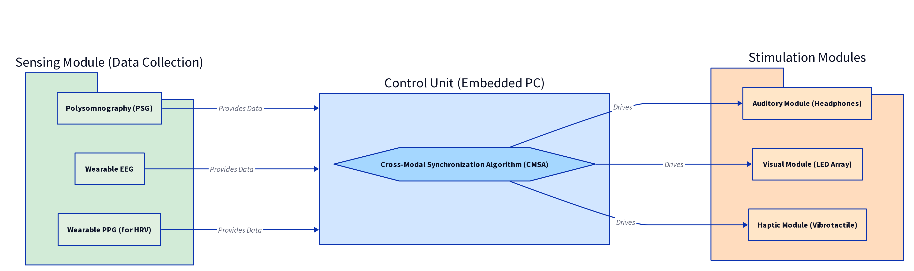
Figure 1. CMATS system architecture diagram

3.2.1 Sensor Module
The sensing module is responsible for collecting the user's physiological data for baseline and post-intervention assessment. In this experiment, smart sleep pads and wearable rings were used as objective sleep measurement tools to obtain key indicators such as sleep latency (SL), total sleep time (TST), waking time after sleep (WASO), and sleep efficiency (SE). Neurophysiological data were obtained through wearable EEG headbands for calculating the power spectral density (PSD) of electroencephalogram (EEG), and the relative power in the δ (0.5-4hz), θ (4-8hz), and α (8-12hz) bands was analyzed using the Welch method. In addition, heart rate variability (HRV) was recorded by PPG sensors integrated into sleep pads and rings. The R-R intervals were extracted, and the time-domain (RMSSD) and frequency-domain (LF/HF ratio) indicators were calculated. Smart sleep pads, wearable rings and wearable EEG headbands form a complete physiological monitoring system.
3.2.2 Control Unit
The control unit is an embedded system that runs a real-time operating system. Its main function is to receive input from the sensing module (EEG/HRV sensor) and execute the cross-modal synchronization algorithm (CMSA) to ensure that the three sensory streams are aligned in time with millisecond-level accuracy. CMSA is defined by the following synchronization functions:
$S(t)=\sum_{m∈\{A,V,H\}}{}λ_{m}∙f_{m}(t)∙Φ_{m}(t)$ (1)
Among them:
S(t) is the total synchronous therapeutic signal of time t.
m represents the modes (A: auditory, V: visual, H: tactile).
$λ_{m}$ is a modal-specific weighting factor (for example, during deep sleep induction).
$f_{m}(t)$ is the time-varying stimulus function of mode m (for example, the frequency of binaural beats, the intensity of light).
$Φ_{m}(t)$ is the phase synchronization function, ensuring that the peak of one stimulus aligns with a specific phase of another stimulus (for example, the visual flicker frequency matches the auditory binaural beat frequency).
3.2.3 Stimulation Module
The stimulation module includes an auditory module using bone conduction headphones, a sleep eye mask embedded with a low-intensity, non-blue light spectrum LED array, and an intelligent sleep pad embedded with a low-frequency linear resonance vibration actuator (LRA). The auditory module's stimulation content consists of binaural beats (carrier frequency 150Hz) and a low-frequency environmental soundscene composed of simple pure synthetic sounds to avoid unnecessary cognitive processing. The system achieves three-stage guidance of brainwave synchronization by regulating the beat frequency: In the first stage (0-30 minutes, to wake up), it linearly decreases from 10Hz (α band) to 6Hz (low θ band); The second stage (30-60 minutes, induction) continues to linearly decline from 6Hz to 2Hz (high δ band); In the third stage (60-120 minutes, synchronized), maintain a constant 1Hz isochronous tone (δ band) to promote slow-wave sleep (SWS). Keep the sound volume within 40dB SPL.
The peak wavelength of the LED array spectrum in the vision module is 630nm, deep red light. Visual stimulation is a set of dynamic light patterns, whose flickering frequency is synchronized with the auditory beat frequency (fV(t)=fA(t)), using optical driving technology. In the first stage, the light intensity will be modulated according to a slow breathing rhythm to enhance relaxation and reduce the level of arousal. The upper limit of light intensity is set at 5lux, which is lower than the melatonin inhibition threshold to ensure safety and comfort.
The tactile module is composed of low-frequency, rhythmic and slight vibrations, simulating the soothing effect brought by shaking or light touch. Its vibration frequency is consistent with the low-frequency band of the auditory and visual synchronous signals and is regulated in three stages: The first stage (0-30 minutes) provides continuous, low-amplitude 5Hz vibration to promote relaxation; The second stage (30-60 minutes) transforms into rhythmic pulse vibration and is synchronized with the θ band variation trajectory (from 6Hz to 2Hz). In the third stage (60-120 minutes), maintain continuous 1Hz ultra-low frequency vibration to enhance the amplitude of the slow oscillation (SOs) characteristic of slow-wave sleep (SWS). The vibration amplitude is set to be almost imperceptible, and its maximum acceleration does not exceed 0.5m/s².
4. Experiments and Results
4.1 Experimental Procedure
Participants in the treatment group were required to immediately use the CMATS system, including the corresponding module equipment, upon entering the bed. The CMATS system worked for 120 minutes, 7 days a week for 6 consecutive weeks (a total of 42 CMATS sessions). The intervention plan is shown in Table 1. The control group received only the same 6-week CBT-I treatment
Table 1. Experimental intervention plan
Week | Session  Frequency | CMATS Session Duration | CBT-I Session Focus
1 | Daily CMATS + 1 CBT-I | 120 minutes | Introduction to CBT-I, Sleep Hygiene Education, Sleep Diary.
2 | Daily CMATS + 1 CBT-I | 120 minutes | Stimulus Control (SC) and Sleep Restriction (SR) introduction.
3 | Daily CMATS + 1 CBT-I | 120 minutes | Cognitive Therapy (CT): Challenging dysfunctional beliefs about sleep.
4 | Daily CMATS + 1 CBT-I | 120 minutes | Relaxation Training (RT) integration with CMATS Phase 1.
5 | Daily CMATS + 1 CBT-I | 120 minutes | Relapse Prevention and Maintenance Strategies.
6 | Daily CMATS + 1 CBT-I | 120 minutes | Review, Final Assessment, and Long-term Plan.

4.2 Results
4.2.1 Objective Sleep Parameters
Table 2 shows the changes in key sleep indicators from baseline to post-intervention in the five groups. Multivariate analysis of variance (ANOVA) showed that there were significant differences in the intervention effects among the groups: The Full-CMATS group was significantly better than the control group and all single-modal groups in terms of the improvement of SL, TST and SE (p<0.01). The SL in the Full-CMATS group decreased by an average of 45.8 minutes and the SE increased by an average of 14.0%.

Table 2. Comparison of Objective Sleep Parameters (PSG) Before and After Intervention
Metric | Group | Baseline  (x ± s) | Post-  Intervention (  x ± s) | Δ  Change | F-value | p-value
 | V-CMATS | 71.0 ± 5.0 | 76.5 ± 4.5 | +5.5
 | H-CMATS | 70.5 ± 5.5 | 77.5 ± 4.0 | +7.0
 | Full-  CMATS | 71.0 ± 5.0 | 85.0 ± 3.5 | +14.0
Total Sleep Time (TST, min) | Control | 315.8 ± 45.1 | 355.2 ± 38.9 | +39.4 | 2.55 | 0.014∗
 | Treatment | 312.5 ± 48.7 | 371.4 ± 35.5 | +58.9 | 4.11 | <  0.001∗∗∗
Sleep  Efficiency (SE, %) | Control | 69.2 ± 5.5 | 77.5 ± 4.1 | +8.3 | 3.88 | <  0.001∗∗∗
 | Treatment | 68.9 ± 6.1 | 83.5 ± 3.5 | +14.6 | 7.52 | <  0.001∗∗∗
Note: p < 0.05, p < 0.01, p < 0.001. δ Change is Post-Intervention minus Baseline.

4.2.2 Subjective Sleep Quality (PSQI)
Figure 2 shows the average PSQI scores of the five groups at baseline and after the intervention. The PSQI score in the Full-CMATS group decreased the most, which was significantly better than that in the control group and the single-mode group. At baseline, the average PSQI scores of each group were comparable (ranging from 14.0±2.0 to 14.5±2.5). After the intervention, the difference in the reduction of the average PSQI score was statistically significant (F(4,95)=15.2,p<0.001). The Full-CMATS group achieved the maximum score of 6.5 (ranging from 14.5±2.5 to 8.0±1.5), outperforming the control group (3.5 points) and all single-module groups (A-CMATS:4.5 points, V-CMATS:3.8 points, H-CMATS:4.2 points).

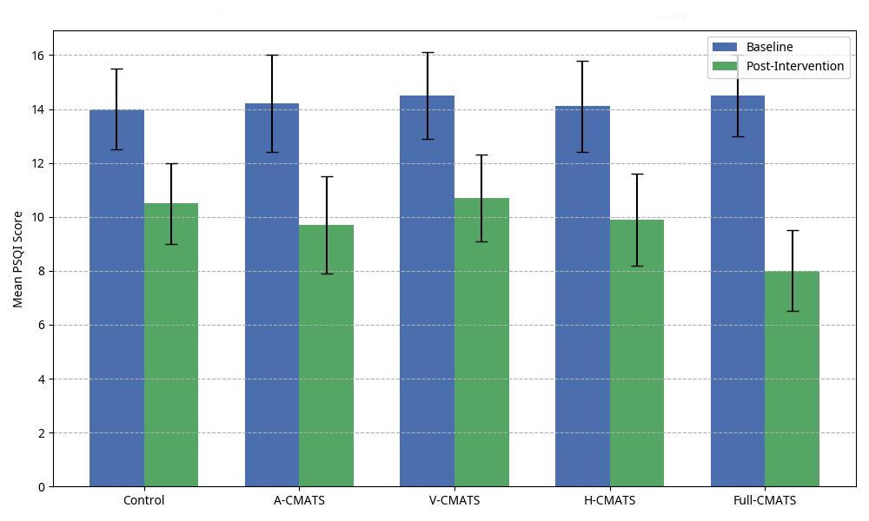
Figure 2. Comparison of Pittsburgh Sleep Quality Index (PSQI) scores among the five intervention groups

4.2.3 Neurophysiological results (EEG and HRV)
4.2.3.1 EEG Power Spectral Density (PSD)
Figure 3 compares the percentage changes in α, θ and δ power of all five groups from baseline to within the first hour after intervention. The Full-CMATS intervention showed the most significant changes on the EEG spectrum, demonstrating obvious synergistic effects. Specifically, the relative power of the α wave (8-12Hz) in the Full-CMATS group decreased by 18.5% (associated with awakening/awakening), which was significantly greater than the 5.2% decrease in the control group (p<0.01). Meanwhile, the relative power of δ waves (0.5-4Hz) increased by 25.1% (associated with deep sleep/slow-wave sleep), significantly higher than the 8.9% increase in the control group (p<0.001). The power of θ waves (4-8Hz) also increased by 15.3% in the treatment group, which was higher than 4.1% in the control group (p<0.05).

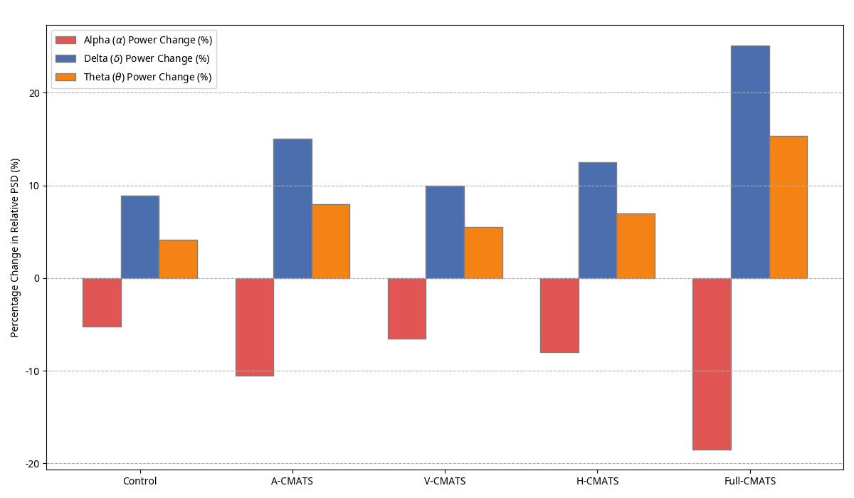
Figure 3. Changes in relative EEG power spectral density (PSD) of the five intervention groups

4.2.3.2 Heart Rate Variability (HRV)
Table 3 provides a detailed description of the changes in key HRV indicators reflecting the balance of the autonomic nervous system (ANS). Compared with all the other groups, the Full-CMATS group showed the most significant parasympathetic dominant transformation, with a significant increase in RMSSD and a significant decrease in the LF/HF ratio (p<0

Table 3. Comparison of Heart Rate Variability (HRV) Metrics Before and After Intervention
Metric | Group | Baseline (x ± s) | Post-Intervention  (x ± s) | Δ Change | t-value | p-value
RMSSD (ms) | Control | 5.2 ± 8.1 | 40.5 ± 7.5 | +5.3 | 2.11 | 0.041∗
 | Treatment | 34.9 ± 7.9 | 51.8 ± 9.2 | +16.9 | 5.98 | <0.001∗∗∗
LF/HF Ratio | Control | 1.85 ± 0.35 | 1.60 ± 0.30 | −0.25 | 2.05 | 0.047∗
 | Treatment | 1.88 ± 0.40 | 1.15 ± 0.25 | −0.73 | 6.55 | <0.001∗∗∗
Note: RMSSD reflects parasympathetic activity; LF/HF ratio reflects sympathovagal balance (lower is more parasympathetic).

5. Analysis and Discussion
The significant improvements in objective PSG indicators (SL, TST, SE) and subjective PSQI scores in the CMATS group indicated that the CMATS group had obvious clinical advantages compared with the use of standard CBT-I alone. A reduction of 42.5 minutes in sleep latency is particularly significant, as prolonged sleep duration is a typical symptom of ID. Compared with all single-modal groups, Full-CMATS produced a stronger synergy than a single method, significantly enhancing the effect. Although auditory stimulation alone was the most effective single approach, adding synchronous visual and tactile inputs in the Full-CMATS group nearly doubled the improvement in key indicators such as sleep latency. This indicates that, compared with isolated stimuli, the brain's sleep-inducing network responds more strongly to a coherent multisensory environment. Cross-modal synchronization may enhance brainwave carrying and autonomic nervous system regulation more than any single modal. CBT-I teaches patients how to manage their awakenings, while CMATS uses designed sensory inputs to physiologically guide the brain and body into a state conducive to sleep.
The contribution of this study lies in the objective neurophysiological verification of the CMATS mechanism. The EEG and HRV results show that cross-modal stimulation is not merely a distraction but can truly regulate the physiological state of the participants. The δ and θ power in the electroencephalogram (EEG) significantly increased, while the α power decreased, indicating that synchronous auditory and visual stimuli (binaural beats and light stimulation) successfully induced brainwave synchronization, enabling neural activity to transition from a waking state dominated by α waves to a deep sleep state dominated by δ waves. Similarly, a significant improvement in HRV indicators (an increase in RMSSD and a decrease in the LF/HF ratio) indicates an enhanced degree of parasympathetic nerve dominance, which is helpful in combating the common sympathetic nerve overarousal in chronic insomnia [19]. These changes indicate that low-frequency tactile and auditory stimuli may activate the vagus nerve pathway, thereby effectively inhibiting the sympathetic nerve activation response and helping the body naturally enter a rest mode.
Compared with the existing dCBT-I platform, the integrated software and hardware system provided by CMATS can offer real-time physiological regulation. Compared with traditional music therapy, CMATS offer a multi-sensory, synchronous and frequency-specific intervention, ensuring higher stimulation control and therapeutic precision. However, this study still has some limitations. Firstly, this randomized controlled trial adopted the pre-programmed open-loop CMATS version. Although the system can provide real-time stimuli with physiological effects, it still cannot adjust these stimuli based on the user's real-time physiological signals. Therefore, future work will focus on achieving a fully closed-loop biofeedback architecture, in which CMSA continuously monitors real-time EEG and HRV data and dynamically ADAPTS to stimulus parameters. This upgrade is expected to maximize the individualized entrainment efficacy and enhance clinical robustness. Secondly, the participants of this study were selected as insomniacs who could sleep alone, and they tried their best to eliminate distractions and possible disturbances to their roommates. In the future, we will continue to research more convenient system devices that do not disturb others. Finally, the intervention period of this study was only six weeks, and the long-term efficacy remains unclear. Therefore, follow-up evaluations need to be conducted at 6 months and 12 months to test the persistence of the efficacy and its potential in preventing recurrence.
6. Conclusion
This study designed and verified the synergistic advantages of the synchronous cross-modal art therapy system (CMATS) as an adjunctive intervention for CBT-I in the treatment of insomnia disorders. Based on the results of five randomized controlled trials (RCTS), we found that the Full-CMATS group had significantly better improvements in objective sleep indicators (SL, TST, SE) and subjective sleep quality (PSQI) than all single-modal intervention groups (A/V/H-CMATS) and the control group (CBT-I Only). It has fully demonstrated the synergistic effect generated by cross-modal synchronous stimulation, achieving the integrated advantage of "the overall effect being greater than the sum of its parts". Further EEG power spectral density (PSD) and HRV analyses revealed clear neurophysiological mechanisms: Full-CMATS induced significant brainwave entrainulation effects (increase in δ and θ power and decrease in α power), and promoted parasympathetic nerve dominance (improvement in HRV indicators), thereby explaining its clinical efficacy in a quantifiable and replicable manner. In addition, this study elevates art therapy to an engineered solution with precise parameter controllability and a mechanism verification foundation, and relies on wearable devices to achieve home monitoring, providing a feasible model for future large-scale, low-cost, and highly compliant digital therapy trials. In conclusion, CMATS offer a scalable, non-pharmaceutical and innovative approach to alleviating insomnia disorders worldwide. This study not only confirms the effectiveness of cross-modal art therapy but also lays a crucial foundation for the development and clinical transformation of the next generation of sleep medicine digital therapies through engineering methodology and neurophysiological evidence.
References
- Bhaskar S, Hemavathy D, Prasad S. Prevalence of chronic insomnia in adult patients and its correlation with medical comorbidities. Journal of family medicine and primary care. 2016 Oct 1;5(4):780-4. https://doi.org/10.4103/2249-4863.201153
- Hafner M, Stepanek M, Taylor J, Troxel WM, Van Stolk C. Why sleep matters—the economic costs of insufficient sleep: a cross-country comparative analysis. Rand health quarterly. 2017 Jan 1;6(4):11.
- Fernandez-Mendoza J, Vgontzas AN. Insomnia and its impact on physical and mental health. Current psychiatry reports. 2013 Dec;15(12):418.
https://doi.org/10.1007/s11920-013-0418-8
- Sateia MJ, Buysse DJ, Krystal AD, Neubauer DN, Heald JL. Clinical practice guideline for the pharmacologic treatment of chronic insomnia in adults: an American Academy of Sleep Medicine clinical practice guideline. Journal of clinical sleep medicine. 2017 Feb 15;13(2):307-49. https://doi.org/10.5664/jcsm.6470
- [x1] Rios P, Cardoso R, Morra D, Nincic V, Goodarzi Z, Farah B, Harricharan S, Morin CM, Leech J, Straus SE, Tricco AC. Comparative effectiveness and safety of pharmacological and non-pharmacological interventions for insomnia: an overview of reviews. Systematic reviews. 2019 Nov 15;8(1):281. https://doi.org/10.1186/s13643-019-1163-9
- 4.Qaseem A, Kansagara D, Forciea MA, Cooke M, Denberg TD, Clinical Guidelines Committee of the American College of Physicians*. Management of chronic insomnia disorder in adults: a clinical practice guideline from the American College of Physicians. Annals of internal medicine. 2016 Jul 19;165(2):125-33. https://doi.org/10.7326/M15-217
- Walker J, Muench A, Perlis ML, Vargas I. Cognitive behavioral therapy for insomnia (CBT-I): a primer. Klinicheskaia i spetsial'naia psikhologiia= Clinical psychology and special education. 2022;11(2):123. https://doi.org/10.17759/cpse.2022110208
- Silvestri R. Sleep and ADHD: A complex and bidirectional relationship. Sleep Medicine Reviews. 2022 May 7;63:101643-. https://doi.org/10.1016/j.smrv.2022.101643
- Luo X, Zhang A, Li H, Li Y, Ying F, Wang X, Yang Q, Zhang Z, Huang G. The role of arts therapies in mitigating Sleep Initiation and Maintenance Disorders: a systematic review. Frontiers in Psychiatry. 2024 May 16;15:1386529. https://doi.org/10.3389/fpsyt.2024.1386529
- Walker J, Muench A, Perlis ML, Vargas I. Cognitive behavioral therapy for insomnia (CBT-I): a primer. Klinicheskaia i spetsial'naia psikhologiia= Clinical psychology and special education. 2022;11(2):123. https://doi.org/10.17759/cpse.2022110208.
- Hwang JW, Lee GE, Woo JH, Kim SM, Kwon JY. Systematic review and meta-analysis on fully automated digital cognitive behavioral therapy for insomnia. npj Digital Medicine. 2025 Mar 12;8(1):157. https://doi.org/10.1038/s41746-025-01514-4.
- Hertenstein E, Feige B, Gmeiner T, Kienzler C, Spiegelhalder K, Johann A, Jansson-Fröjmark M, Palagini L, Rücker G, Riemann D, Baglioni C. Insomnia as a predictor of mental disorders: a systematic review and meta-analysis. Sleep medicine reviews. 2019 Feb 1;43:96-105. https://doi.org/10.1016/j.smrv.2018.10.006
- Knill PJ, Levine EG, Levine SK. Principles and practice of expressive arts therapy: Toward a therapeutic aesthetics. Jessica Kingsley Publishers; 2005.
- Wang YK, Chen CY. Integrating Mobile Devices and Wearable Technology for Optimal Sleep Conditions. Applied Sciences. 2023 Sep 1;13(17):9921. https://doi.org/10.3390/app13179921.
- He C, Wang Q, Lou J, Liu Z, Ying F. Real-Time Physiological Signal Feedback for Anxiety Intervention Music System for Postpartum Women. InInternational Symposium on World Ecological Design 2024 (pp. 378-386). IOS Press. https://doi.org/10.3233/FAIA240041
- Iber C. The AASM manual for the scoring of sleep and associated events: rules, terminology, and technical specification. (No Title). 2007.
- Shaffer F, Ginsberg JP. An overview of heart rate variability metrics and norms. Frontiers in public health. 2017 Sep 28;5:258.
https://doi.org/10.3389/fpubh.2017.00258
- Recio-Rodriguez JI, Fernandez-Crespo M, Sanchez-Aguadero N, Gonzalez-Sanchez J, Garcia-Yu IA, Alonso-Dominguez R, Chiu HY, Tsai PS, Lee HC, Rihuete-Galve MI. Neurofeedback to enhance sleep quality and insomnia: a systematic review and meta-analysis of randomized clinical trials. Frontiers in Neuroscience. 2024 Nov 6;18:1450163. https://doi.org/10.3389/fnins.2024.1450163
- Bonnet MH, Arand DL. Hyperarousal and insomnia: state of the science. Sleep medicine reviews. 2010 Feb 1;14(1):9-15. https://doi.org/10.1016/j.smrv.2009.05.002

Corresponding author. Email: prima@gmail.com

